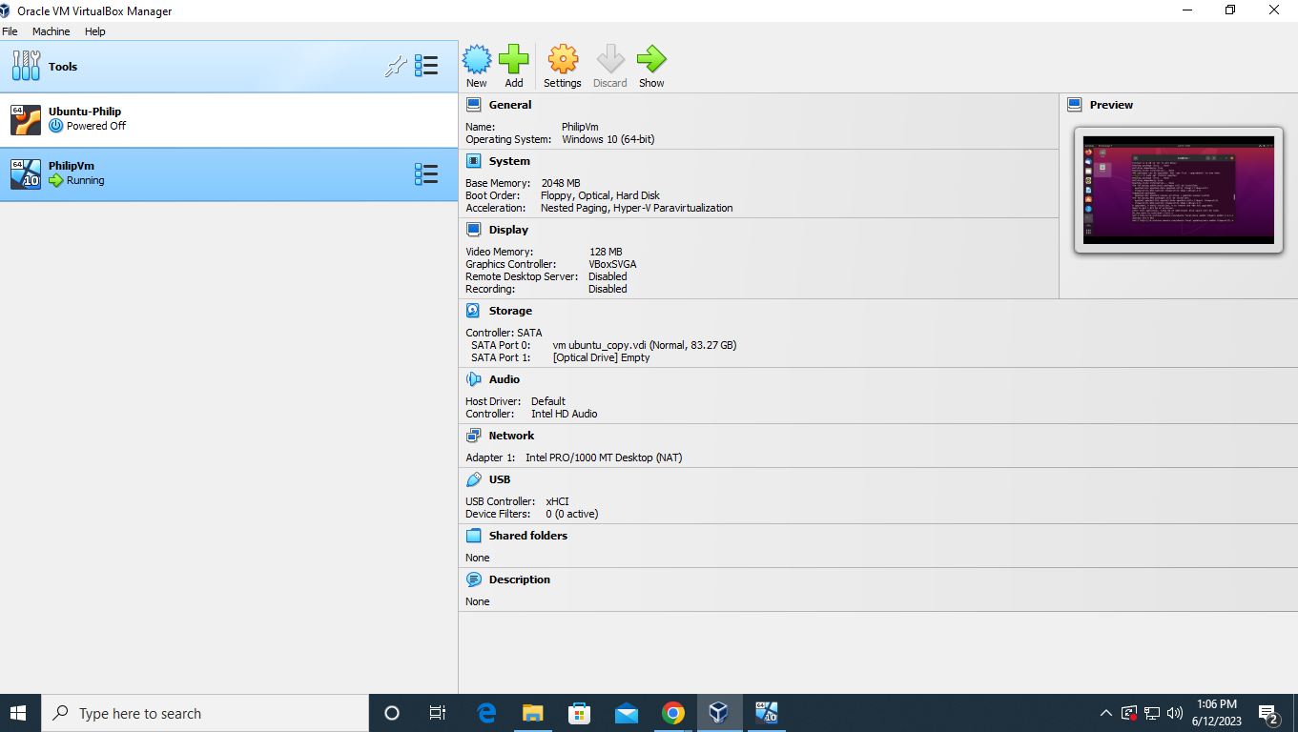

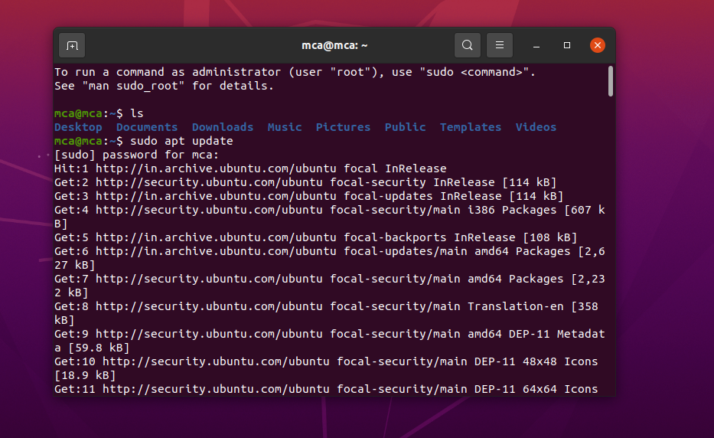

Installing apache2

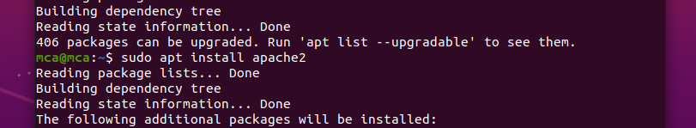

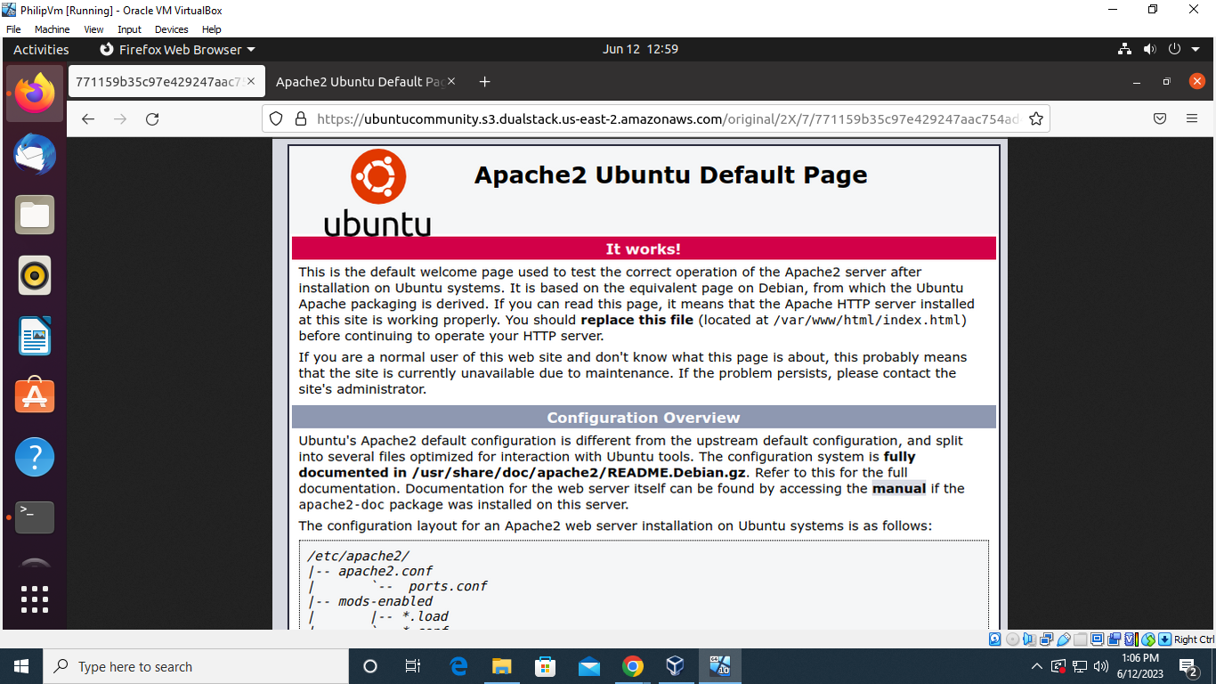

Checking status apache

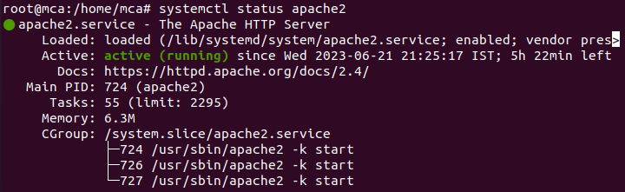

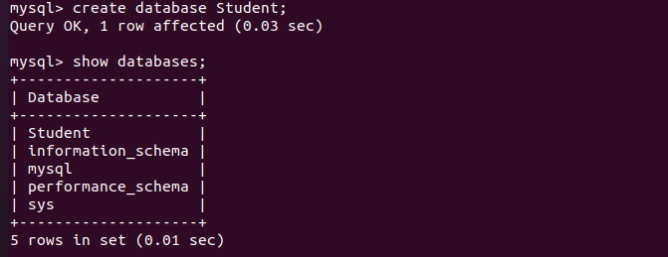

Installing mysql

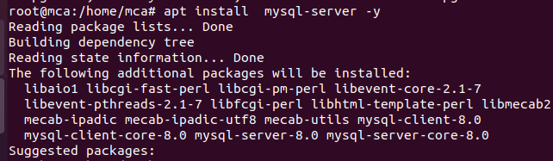

Checking status mysql

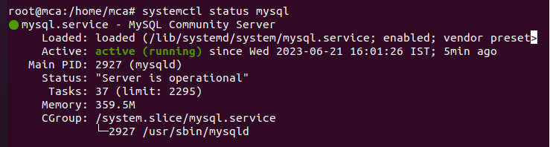

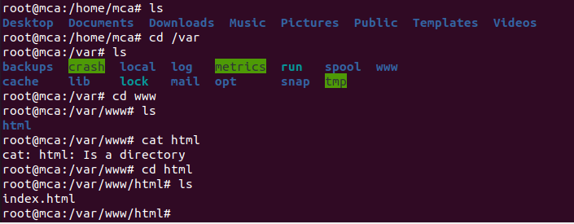

Installing php

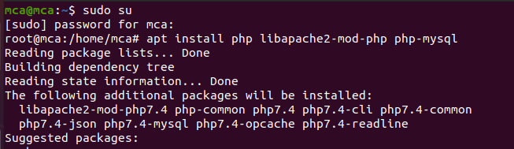

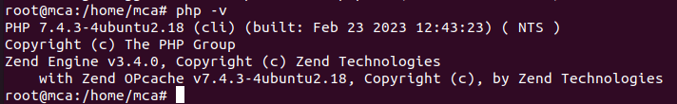

Creating php file



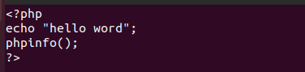

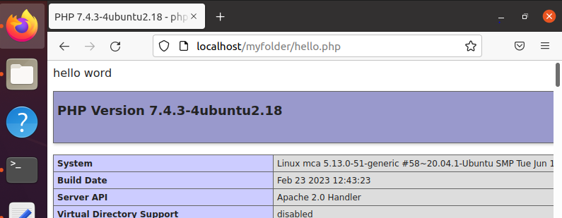

**Install phpmyadmin**

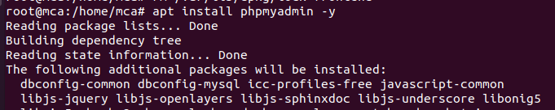



**Modify apache2.conf file with**

“Include /etc/phpmyadmin/apache.conf”



**Add this include statement in apache2.conf file**



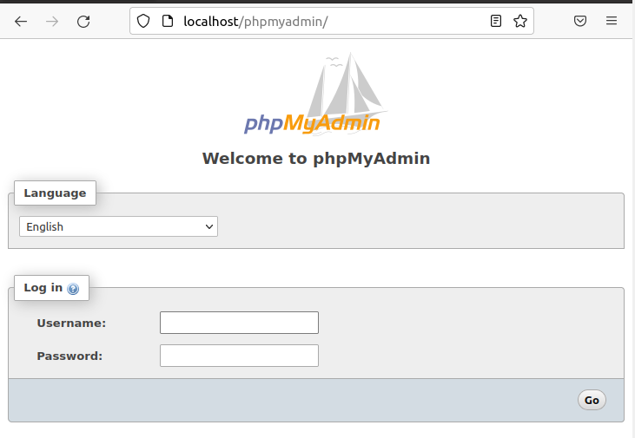

**Setting password**

**Move to mysql**

**Then**

